

Rocket.Chat : Technical assessment - Rocket.Chat Enterprise Solutions team

Technical Support Analyst position – PART 2

Submitted by : Millard Louise Pascua

Date : 10/28/2020

Summary of this Document:

This document provides the results of each request/response for each operation that are screenshots. The API calls are done through the server itself.

* Create a new user via an API endpoint:
  + 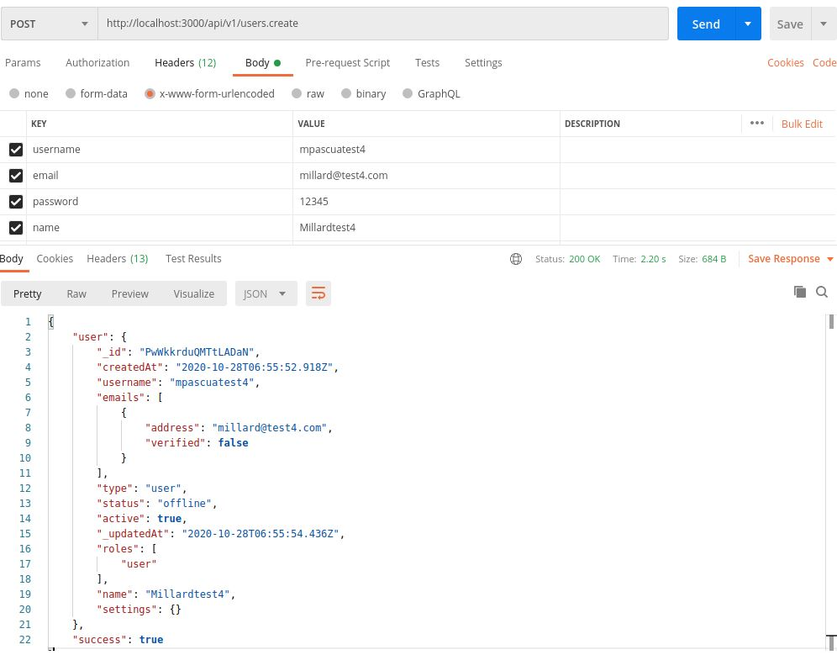Body:
  + 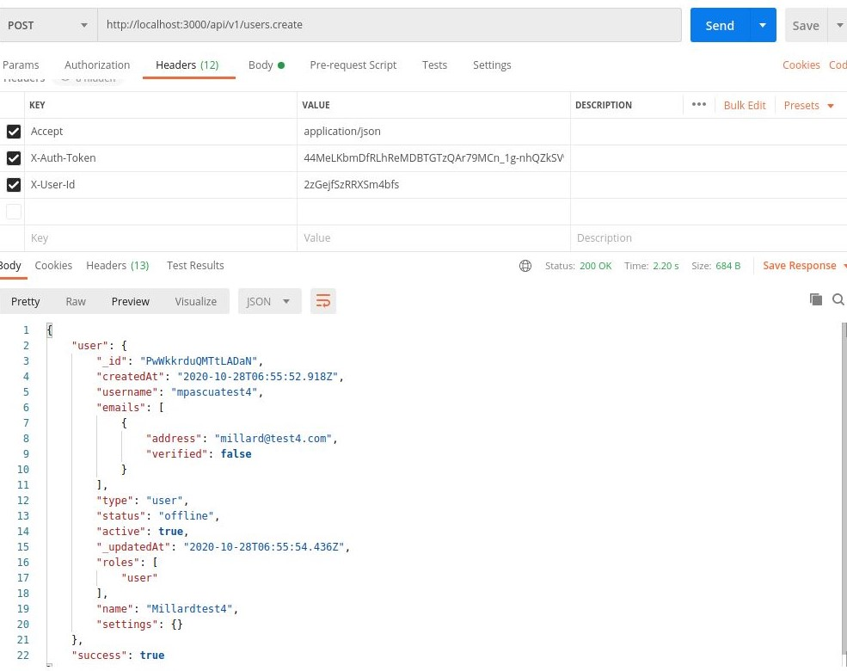Headers:
* Get the room information via an API endpoint
  + 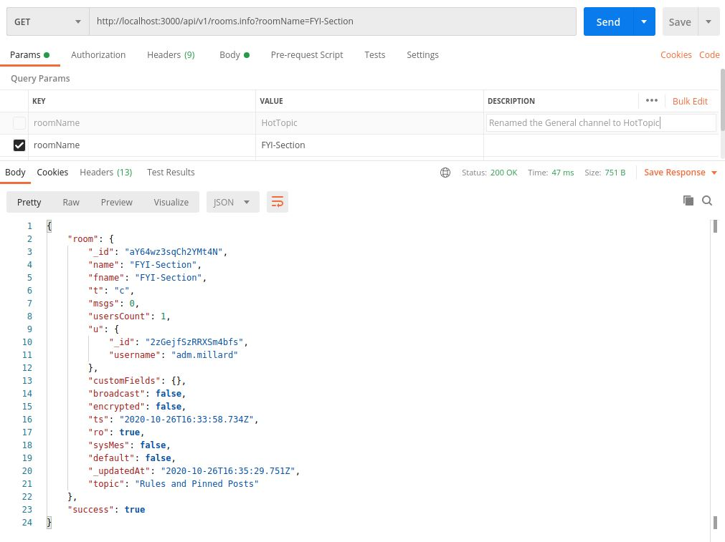Parameters:
  + 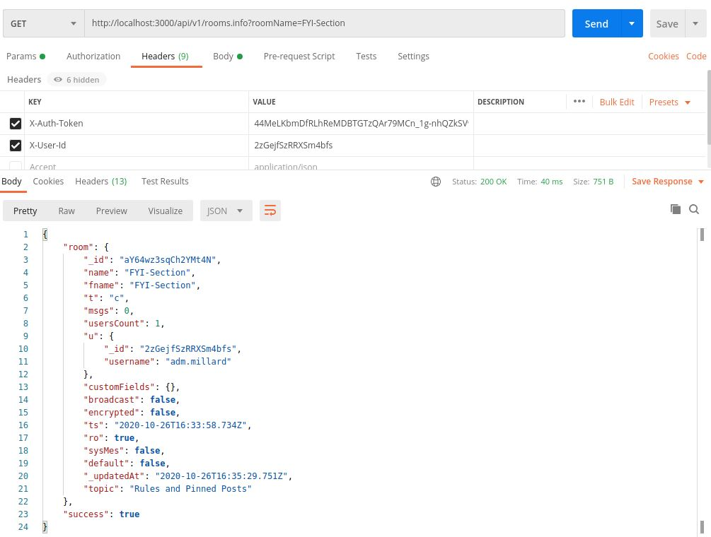Headers:
* Get a list of all user roles in the system via an API endpoint.
  + \*Please take note that I provided two request/response, because it stated that “get a list of all user roles”. I’m not sure if it meant to get the user roles list or a list of all user and their roles.\*
  + 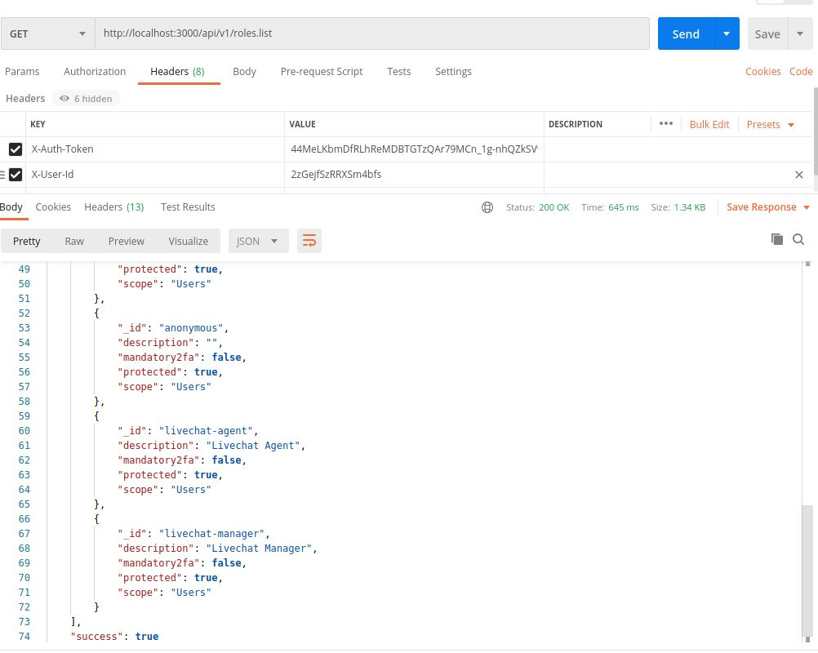User Roles List
  + 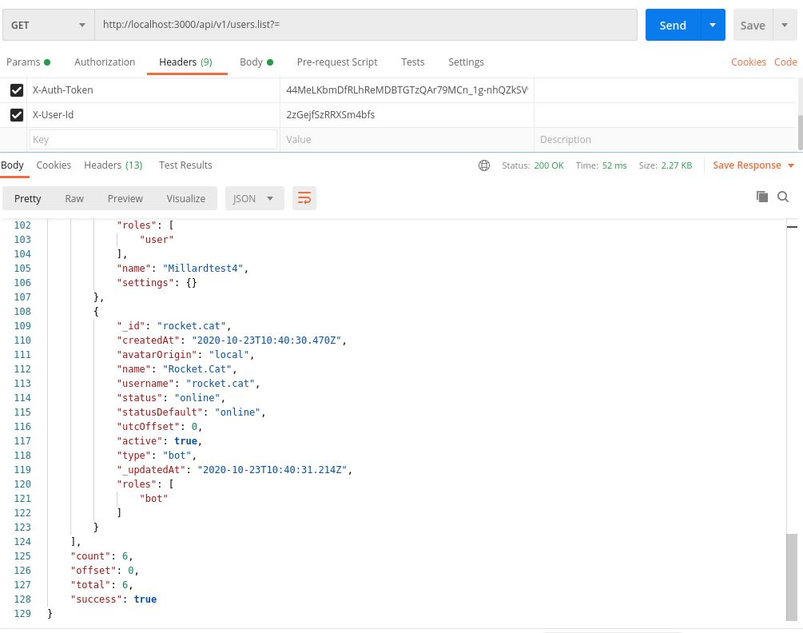A list of Users with Roles.